Week of | Monday  9/17 | Tuesday  9/18  ½ day for students | Wednesday  9/19 | Thursday  9/20 | Friday  9/21
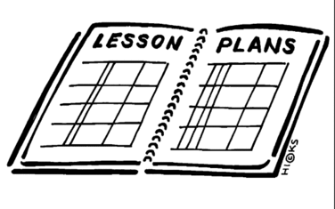  Lesson | Constitution day | 1. Watch channel one news  2. Complete a vocabulary quiz | 1. Read pages 69-70 in the Text book  2. Look back at the Jamestown foldable. Discuss 3 difference and similarities between Jamestown and Plymouth colony  3. Cut out the Venn Diagram and glue it into page 4 of the notebooks and complete | 1. Compare colonial regions by singing into Moodle and completing the chart  2. once the chart is correct, copy the answers onto the paper chart and glue on to page 5 of the INB | 1. Read/listen to chapter 4, section 1  2. Write out the answers to questions 1-3 on page 106 and a and b on page 103
Content Objective |  |  | Students will be able to show analysis of the Plymouth colony and Jamestown to understand why colonists declared independence by completing a Venn diagram with 4-5 differences and 2-3 similarities. | Students will be able to comprehend the differences in each colonial region (New England, Middle colonies, and Southern colonies) leading the colonist to declare independence by completing a chart that compares each region. | Students will be able to demonstrate knowledge of how the English ideas about Government influenced the colonist’s ideas of government by reading/listening to chapter 4.1 and writing a summary of the text.
Language Objective |  |  | Students will orally review what they know about Jamestown with a table partner and then share out. | Students will orally discuss prior knowledge of colonial regions with a table partner and then share out (states, economy, geography) | Students will orally write a list of 3 ideas that the English had about government that influenced colonists.
Vocabulary |  |  | - Magna Carta  - Legislature  - Self-Government  - Virginia Company  - Jamestown | - Indentured Servant  - House of Burgesses  - Quakers  - Puritan  - Mayflower Compact
Assessment 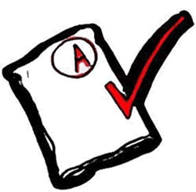 |  |  | Identify 4-5 facts that make each colony unique and 2-3 that each colony shares | Correctly identify all facts about each region (it can take any number of tries to do correctly) | Correctly identify 3 ideas the English had about government.
GLCE |  |  | F1.1 Describe the ideas, experiences, and interactions that influenced the colonists’ decisions to declare independence by analyzing: • the core values declared as self-evident truths (“core principles”) held by the founding fathers • experiences with self-government (e.g., House of Burgesses and town meetings) changing interactions with the royal government of Great Britain after the French and Indian War | F1.1 Describe the ideas, experiences, and interactions that influenced the colonists’ decisions to declare independence by analyzing: • the core values declared as self-evident truths (“core principles”) held by the founding fathers • experiences with self-government (e.g., House of Burgesses and town meetings) changing interactions with the royal government of Great Britain after the French and Indian War | F1.1 Describe the ideas, experiences, and interactions that influenced the colonists’ decisions to declare independence by analyzing: • the core values declared as self-evident truths (“core principles”) held by the founding fathers • experiences with self-government (e.g., House of Burgesses and town meetings) changing interactions with the royal government of Great Britain after the French and Indian War

