Week of 9-11 to 9-15 | Monday | Tuesday  ½ day | Wednesday  Open House  6:30 -8 | Thursday | Friday
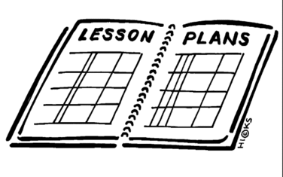  Lesson | 1. Finish vocabulary entrance exam part 1  2. Complete vocabulary entrance exam part2 | 1. PBIS pep rally 9-11  1st hour watch channel one news | 1. Complete Social Studies 8th grade Entrance Exam  2. Complete Core Democratic Values worksheet on Common Good and Equality | 1. Complete Core Democratic Values worksheets for Justice, Diversity, and Life, liberty and the Pursuit of Happiness  2. Set up notebooks including coloring cover page  3. look at data folders and fill in the entrance scores for vocabulary and Entrance exams  4. Complete the self-reflections page. | 1. Discuss the Constitution day vocabulary words  2. in groups, read the Preamble to the Constitution. As a group write the basic meaning of the preamble as a tweet.  3. in groups, research one of the articles of Constitution and create a way to explain it to the rest of the class (poem, song, cartoon, power point, etc.) It must be clear, focused and to the point.
Content Objective | Students will be able to demonstrate prior knowledge of key vocabulary for 8th grade social studies. |  | Students will be able to demonstrate prior knowledge of the curriculum of 8th grade social studies. | Students will be able to demonstrate knowledge of the Core Democratic Values. | Students will be able to demonstrate knowledge of the meaning of the preamble of the constitution and the basic meaning of each of the articles.
Language Objective | Students will write to show knowledge of key vocabulary words |  | Students will write to show prior knowledge of 8th grade curriculum for social studies. | Students will write and speak to demonstrate knowledge of the Core Democratic Values. | Students will orally discuss the meaning of the preamble and one of the articles of the Constitution.
Learning Target | I can demonstrate prior knowledge of key vocabulary for 8th grade social studies | I can | I can demonstrate prior knowledge of the curriculum of 8th grade social studies | I can demonstrate knowledge of the Core Democratic Values. | I can demonstrate knowledge of the meaning of the preamble of the constitution and the basic meaning of each of the articles.
Vocabulary |  |  |  |  | Union  Justice  Ensure  Domestic  Tranquility  Common defense  Promote  General welfare  Ordain  Establish  Constitution
Assessment |  |  |  |  | Presentations of article projects
GLCE

