Week of | Monday  9/10 | Tuesday  9/11 | Wednesday  9/12  Open House 630-8  Early dismissal 12:45 | Thursday  9/13 | Friday  9/14
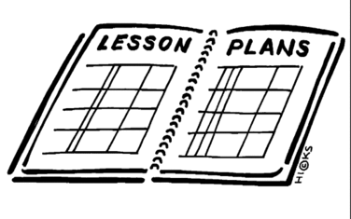  Lesson | 1. Complete Vocabulary Entrance exam part 2 | 1. Complete the 8th grade Entrance Exam | 1. Set up interactive notebooks  - number the pages  -color the cover  -glue in on the cover and the table of contents page. | 1. Read “Magna Carta” article and answer questions  2. With table partners, read the list of words and identify any that are already known and discuss their meanings.  3. Write the new concepts/vocabulary words in the interactive notebook.  4. Find the idea/definition for each word and write it down. | 1. Read pages 45-50 of Everything you need to ace American History  2. Cut out and glue the foldable into the Interactive Notebook (INB)  3. Complete the activity using the text that was read.
Content Objective | Entrance Exam | Entrance Exam | Early Release  Notebook set up | Students will be able to demonstrate understanding of key vocabulary words and concepts about the beginning of colonies, governing bodies, and self-government by defining and explaining words and concepts in the INB. | Students will be able to demonstrate understanding of the ideas, experiences and interactions of colonists that led to successful self-government by studying Jamestown and identifying reasons for the location choice, the difficulties that were faced, and who the settlers were.
Language Objective |  |  |  | Students will orally identify concepts/terms that they are already familiar with by reading the list of words with a table partner and then discuss the meanings. | Students will orally identify key terms to aid in comprehension of the idea of self-government:  -Magna Carta  -Legislative  -House of Burgesses  -Mayflower Compact  -Town Meetings
Vocabulary |  |  |  | - Magna Carta  - Legislature  - Self-Government  - Virginia Company  - Jamestown | - Indentured Servant  - House of Burgesses  - Quakers  - Puritan  - Mayflower Compact
Assessment |  |  |  | Correctly write the description or definition for 10/10 key terms/ideas. | Correctly identify 2/2 reasons for the location choice of Jamestown  2/3 difficulties faced  2/3 characteristics of the settlers
GLCE |  |  |  | F1.1 Describe the ideas, experiences, and interactions that influenced the colonists’ decisions to declare independence by analyzing: • the core values declared as self-evident truths (“core principles”) held by the founding fathers • experiences with self-government (e.g., House of Burgesses and town meetings) changing interactions with the royal government of Great Britain after the French and Indian War | F1.1 Describe the ideas, experiences, and interactions that influenced the colonists’ decisions to declare independence by analyzing: • the core values declared as self-evident truths (“core principles”) held by the founding fathers • experiences with self-government (e.g., House of Burgesses and town meetings) changing interactions with the royal government of Great Britain after the French and Indian War

