 | Week of  6/4 – 6/8 |  | Monday |  | Tuesday |  | Wednesday |  | Thursday |  | Friday  ½ day
 | 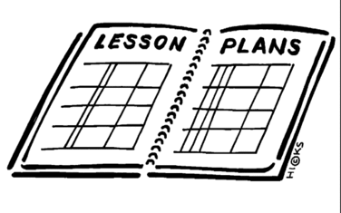  Lesson |  | - Hand out yearlong vocabulary lists  - Complete Unit 5 study guide |  | Take Vocabulary exit exam part 1 |  | Take Vocabulary exit exam part 2 |  | Complete the 8th grade social studies exit exam review guide
 | Content Objective |  | Students will be able to complete a review guide for chapter 5.
 | Language Objective |  | Students will orally review the 3 plans for reconstruction and identify which one was used.
 | Learning Target  Outcomes |  | I can complete a review guide for Unit 5 – the Civil War.
 | Vocabulary
GLCE |  | 8 – U5.3.1 Describe the different positions concerning the reconstruction of Southern society and the nation, including the positions of President Abraham Lincoln, President Andrew Johnson, Republicans, and African Americans.  8 – U5.3.2 Describe the early responses to the end of the Civil War by describing the  • policies of the Freedmen’s Bureau  • restrictions placed on the rights and opportunities of freedmen, including racial segregation and Black Codes  8 – U5.3.3 Describe the new role of African Americans in local, state and federal government in the years after the Civil War and the resistance of Southern whites to this change, including the Ku Klux Klan.  8 – U5.3.4 Analyze the intent and the effect of the Thirteenth, Fourteenth, and Fifteenth Amendments to the Constitution.  8 – U5.3.5 Explain the decision to remove Union troops in 1877 and describe its impact on Americans.

