 | Week of  6/11 – 6/14 |  | Monday |  | Tuesday |  | Wednesday |  | Thursday |  | Friday
 | 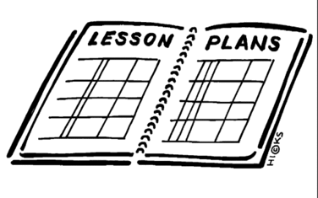  Lesson |  | Exit Exam |  | Civil War Jeopardy |  | Tile Signing |  | ½ day  Last Day |  | TWD
 | Content Objective
 | Language Objective
Learning Target
Outcomes
 | Vocabulary
GLCE

