Week of  5/29 to 6/2 | Monday | Tuesday | Wednesday | Thursday | Friday  ½ day
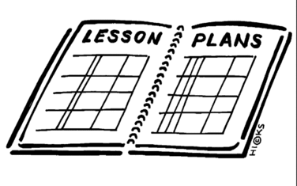  Lesson | No School | 1. Continue any presentations  2. Vocabulary review with white boards –I give a definition they write a word or I give a word they write it in a sentence in pairs.  3. Reconstruction – identify Lincoln’s plan and the Wade-Davis Bill and the Freedmen’s Bureau (16.1) | 1. Vocabulary quiz  2. Explain The thirteenth, Fourteenth, and fifteenth amendments. (16.2)  3. Understand the Radical reconstruction that took place. (16.2)  4. Understand the effects on African Americans. (16.3) | 1. Unit 5 Exam review | *assembly for 9th grade officers from 9-10  Channel One current event.
Content Objective | No School | Students will be able to describe the different positions concerning the reconstruction of Southern Society and the nation by reading text and discussing Lincoln’s, Johnson’s and African American’s opinions about reconstruction. | Students will be able to Analyze the intent and the effect of the Thirteenth, Fourteenth, and Fifteenth Amendments by reading and discussing each of the amendments and why they were created. | Students will be able to demonstrate knowledge the beginning of the Civil War, major battles of the Civil War, and reconstruction by completing a study guide.
Language Objective | No School | Students will orally discuss reconstruction of Southern Society. | Students will write to Analyze the intent and the effect of the Thirteenth, Fourteenth, and Fifteenth Amendments. | Students will write to demonstrate knowledge of the civil war.
Learning Target | No School | I can identify Lincoln’s plan and the Wade-Davis Bill and the Freedmen’s Bureau. | I can explain The thirteenth, Fourteenth, and fifteenth amendments.  I can explain the Radical reconstruction that took place  I can explain the effects of reconstruction on African Americans. | I can answer questions about the beginning of the Civil War, major battles of the Civil War, and reconstruction.
Vocabulary | No School | None | None | None | None
Assessment | No School | Questions | Chart | Study guide
GLCE | No School | 8 – U5.3.1 Describe the different positions concerning the reconstruction of Southern society and the nation, including the positions of President Abraham Lincoln, President Andrew Johnson, Republicans, and African Americans. | 8 – U5.3.4 Analyze the intent and the effect of the Thirteenth, Fourteenth, and Fifteenth Amendments to the Constitution

