 | Week of  5/28 – 6/1 |  | Monday |  | Tuesday |  | Wednesday |  | Thursday |  | Friday  ½ day
 | 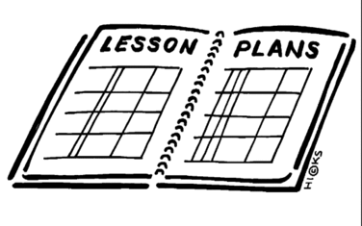  Lesson |  | NO SCHOOL |  | - Review/finish Reconstruction plans  - Go over answers  - Take reconstruction quiz |  | - Use chapter 16 in the text to complete questions about the end of the war and the role of the African Americans in government |  | - Analyze the 13, 14, 15 amendments  - What do they say? What is the impact of each at that time in history? What is the impact of them today? |  | 8th grade officer speeches
 | Content Objective |  | NO SCHOOL |  | Students will be able to identify the three plans of reconstruction and the person/group that presented each plan. |  | Students will be able to demonstrate knowledge of the early responses to the end of the Civil War by describing the policies of the Freedmen’s Bureau, and the restrictions placed on the rights and opportunities of freedmen, including racial segregation and Black Codes.  Students will also be able to describe the new role of African Americans in local, state and federal government in the years after the Civil War and the resistance of Southern whites to this change, including the Ku Klux Klan |  | Students will be able to Identify the intent of the 13th, 14th, and 15th amendments and analyze the impact in history and present day of each by discussing each of them and determine the intent and impact.
 | Language Objective |  | NO SCHOOL |  | Students will orally explain what reconstruction is and how it applies to the end of the Civil War. |  | Students will orally discuss the changes the nation faced as the civil war ended. |  | Students will orally discuss what they know about amendments to the constitution and how and why they happen.
 | Learning Target  Outcomes |  | NO SCHOOL |  | I can explain all three reconstruction plans and identify who presented each of the plans. |  | I can explain the results of the end of the war for the south and the role of African Americans in the government post-civil war. |  | I can explain what an amendment to the constitution is and what the intend and impact of the 13th, 14th, and 15th amendments were.
 | Vocabulary |  | NO SCHOOL
GLCE |  | NO SCHOOL |  |  |  | 8 – U5.3.2 Describe the early responses to the end of the Civil War by describing the  • policies of the Freedmen’s Bureau  • restrictions placed on the rights and opportunities of freedmen, including racial segregation and Black Codes  8 – U5.3.3 Describe the new role of African Americans in local, state and federal government in the years after the Civil War and the resistance of Southern whites to this change, including the Ku Klux Klan. |  | 8 – U5.3.4 Analyze the intent and the effect of the Thirteenth, Fourteenth, and Fifteenth Amendments to the Constitution.  .  .

