Week of  5/14 – 5/18 | Monday | Tuesday | Wednesday | Thursday  Out at PD | Friday
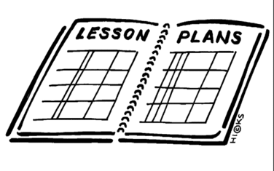  Lesson | - Work on researching the battles and completing the project | - Begin Presentation on Battle projects | - Vocabulary Quiz  - Create a time line of the events of the civil war | - Review the Sectional Tension chart  - Review the Timeline of the Battles  - Begin writing a type 3 | - Complete a teacher led edit and a student led edit for the type 3
Content Objective | Students will be able to analyze critical events and battles of the Civil war to explain why the north won by researching a specific battle and creating a project that displays the research. | Students will be able to analyze critical events and battles of the Civil war to explain why the north won by researching a specific battle and creating a project that displays the research and presenting their finding to the class. | Students will be able to demonstrate knowledge of critical battles and events in the war by creating a timeline of the key battles based on their notes for the project presentations. | Students will be able to analyze the events leading up to the war and the battles of the war to make an argument about whether the war should have happened or not. | Students will be able to write a thesis argument and use supporting claims with clear reason and relevant evidence.
Language Objective | Students will orally explain what they know about the their battle to their a/b partner. | Students will orally present the battle they researched. | Students will write to demonstrate the knowledge they gained from listening to presentations on specific battle of the Civil war. | Students will write to analyze the civil war, making sure to use relevant vocabulary in the writing. | Students will orally read their paper to a partner.
Learning Target  Outcomes | I can continue researching a specific battle from the Civil War. | I can present my research on a battle form the Civil War. | I can create a timeline of the events from the start of the Civil War to the end. | I can make an argument to support my opinion on “Should the Civil War have happened?” | I can edit my paper with the help of the my peers and teacher.
Vocabulary |  |  | - Vocabulary Quiz
GLCE | 8 – U5.2.2 Make an argument to explain the reasons why the North won the Civil War by considering the  • critical events and battles in the war  • the political and military leadership of the North and South  • the respective advantages and disadvantages, including geographic, demographic, economic and technological | 8 – U5.2.2 Make an argument to explain the reasons why the North won the Civil War by considering the  • critical events and battles in the war  • the political and military leadership of the North and South  • the respective advantages and disadvantages, including geographic, demographic, economic and technological | 8 – U5.2.2 Make an argument to explain the reasons why the North won the Civil War by considering the  • critical events and battles in the war  • the political and military leadership of the North and South  • the respective advantages and disadvantages, including geographic, demographic, economic and technological | 8 – U5.2.2 Make an argument to explain the reasons why the North won the Civil War by considering the  • critical events and battles in the war  • the political and military leadership of the North and South  • the respective advantages and disadvantages, including geographic, demographic, economic and technological | CCSS - W8.1  Write arguments to support claims with clear reasons and relevant evidence

