Week of | Monday  12/2 | Tuesday  12/3 | Wednesday  12/4 | Thursday  12/5 | Friday  12/6
Lesson  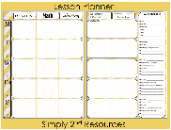 | - Unit 2 review Game | - Unit 2 test | - Go over the answers to unit 2  - Put the unit 3 GLCE Page in the notebook  - Put vocab words and definition’s in the notebook  - Uses quizzes for vocabulary review | - Review vocabulary words  - Read Mi Open Source book (MOSB) chapter 3, section 1  - Take notes and complete 3.1 and share.  - Complete the exit ticket: What did Washington do to set up the New government? | - Read MOSB chapter 3, section 2  - Write questions in book (how did challenges the new nation face build a model for the future government)  - Outline the troubles in the northwest territory, Europe, citizen Genet Affair, Jays Treaty, and Pinckney Treaty.
Content Objective |  |  | Students will be able to demonstrate knowledge of key vocabulary words by reviewing them using a quizzes format from eduprotocals. | Students will be able to demonstrate comprehension of Washington’s perspective on the most significant challenges the new nation faced by summarizing text as they read then completing an exit ticket. | Students will be able to demonstrate comprehension of the changing relationship of the U. S. and other nations by summarizing treaties that were made by the U.S. with other nations in an outline format.
Language Objective |  |  | Students will orally explain the meaning of each vocabulary word and use it in a sentence. | Students will orally use 3 vocabulary words in sentences.  Cabinet  Excise  Treaty  Precedent  Tariff  Unconstitutional  impressment | Students will orally explain one thing Washington did to set up the new government using a sentence stem:  On thing Washington did while setting up the new government was…
Vocabulary  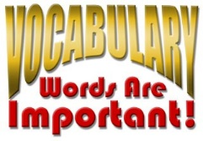 |  |  | Cabinet  Excise  Treaty  Precedent  Tariff  Unconstitutional  impressment
Assessment  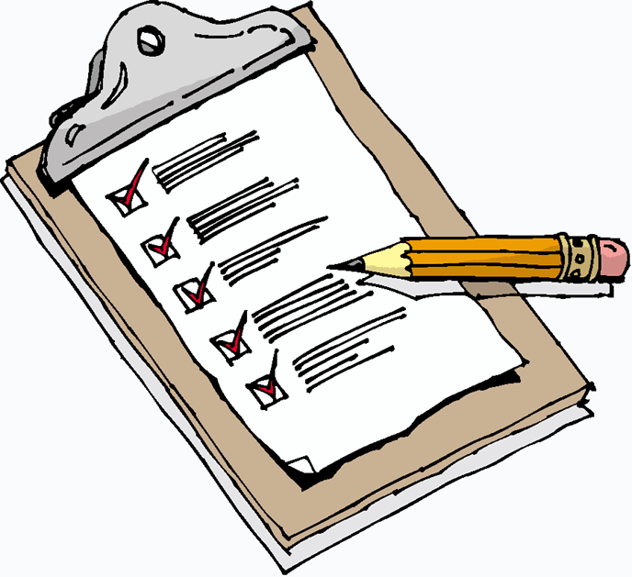 | Review game | Unit 2 test | Vocabulary  Quizzes | Summary | Outline
GLCE |  |  |  | 8 – U4.1.1 Washington’s Farewell – use President George Washington’s farewell  address to analyze Washington’s perspective on the most significant challenges the  new nation faced. | 8 – U4.1.2 Establishing America’s Place in the World – assess the changes in  America’s relationships with other nations by analyzing the origins, intents, and  purposes of treaties.

