Week of | Monday  11/4 | Tuesday  11/5  No School | Wednesday  11/6  Field Trip | Thursday  11/7 | Friday  11/8  ½ day
Lesson  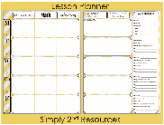 | - PSAT 1st - 4th hour | - No School | - Field Trip to the Toledo Walleyes | - Quiz on Articles of Confederation and Constitutional Convention | - Return all papers and review 1st quarter grades.
Content Objective |  |  |  | Students will be able to demonstrate comprehension of what the Articles of Confederation state and the Constructional Convention by Completing and open book quiz.
Language Objective |  |  |  | Students will orally Review what the Articles of Confederation state and what was debated at the Constructional convention using a sentence stem:  The Articles of Confederation have a ____ government because…  The issues it caused were…  One issue debated at the constructional convention was…
Vocabulary

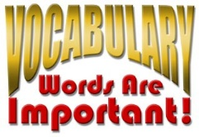
Assessment |  |  |  | Quiz
GLCE |  |  |  | 8 – U3.3.1 Explain the reasons for the adoption and subsequent failure of the Articles of  Confederation (e.g., why its drafters created a weak central government, challenges the nation  faced under the Articles, Shays’ Rebellion, disputes over western lands). (C2)  8 – U3.3.2 Identify economic and political questions facing the nation during the period of the Articles of  Confederation and the opening of the Constitutional Convention. (E1.4)  8 – U3.3.3 Describe the major issues debated at the Constitutional Convention including the distribution  of political power, conduct of foreign affairs, rights of individuals, rights of states, election of the  executive, and slavery as a regional and federal issue.

