Week of  11/20 – 11/24 | Monday | Tuesday | Wednesday  ½ day | Thursday  No School | Friday  No school
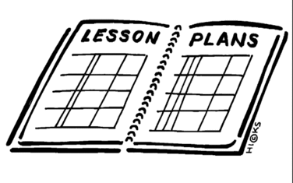  Lesson | 1. Fishbowl activity | 1. Listen to the Constitution Song  2. Read the Preamble and discuss its meaning.  3. Complete and interactive notebook activity identifying all 7 articles of the constitution | PBIS celebration | No School | No School
Content Objective | Students will be able to evaluate the perspective of the federalists and the anti-federalists regarding the ratification of Constitution by presenting a viewpoint and justifying it with an argument. | Students will be able to understand how the constitution resolved major issues debated at the constitution convention by explaining each article of the constitution and why it was written. | PBIS | No School | No School
Language Objective | Students will orally present their assigned perspective and justify it with arguments. | Students will orally discuss the preamble and what is meant by “We the People…” | PBIS | No School | No School
Learning Target | I can present the perspective of the federalist or the Anti-federalist and defend that perspective with an argument. | I can identify what each article of the constitution states and why it is written. | PBIS | No School | No School
Vocabulary | - No Vocabulary this week |  |  | No School | No School
Assessment 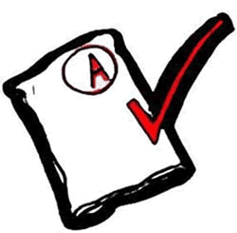 | Fishbowl | Interactive notebook activity | PBIS | No School | No School
GLCE | 8 – U3.3.5 Analyze the debates over the ratification of the Constitution from the perspectives of Federalists and Anti-Federalists and describe how the states ratified the Constitution. | 8 – U3.3.4 Explain how the new constitution resolved (or compromised) the major issues including sharing, separating, and checking of power among federal government institutions, dual sovereignty (state-federal power), rights of individuals, the Electoral College, the Three-Fifths Compromise, and the Great Compromise. | PBIS | No School | No School

