Week of | Monday  10/7 | Tuesday  10/8 | Wednesday  10/9 | Thursday  10/10 | Friday  10/11
Lesson  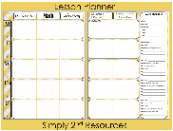 | - Use Claim Evidence, Reasoning worksheet to complete type 3 essay. | - Geo Bee Practice  - Read chapter 5, section 1 in the text books  - Add vocabulary to the notebooks  - Discuss the text. | - Understand the changing relationship of the colonists and others  - Complete the pre-revolutionary war historical events sheet in the INB  - Watch Liberty Kids video (Boston Teac Part and Intolerable acts) | - Geo Bee Practice  - Finish pre-revolutionary war historical events sheet  - Watch Mr. Betts class – start of the Revolutionary war  - Watch Liberty Kids (Midnight ride and Lexington and Concorde.) | - Complete the Tension builds chart in the INB.
Content Objective | Students will be able to demonstrate Analysis of the Declaration of Independence, including the grievances at the end of the  document, and describe the role this document played in expressing colonists view of government by completing a Claim, evidence, reason chart. | Students will be able to demonstrate knowledge of the reason’s colonist chose to separate from Great Britain by Reading about and discussing the trouble that was happening within the colonies. | Students will be able to demonstrate Comprehension of the reason’s colonist chose to separate from Great Britain by identifying events that caused a change in the relationship between the colonists and Britain. | Students will be able to demonstrate evaluation of the reason’s colonist chose to separate from Great Britain by identifying and justifying the start of the revolutionary war on a Think – Pair – share. | Students will be able to demonstrate synthesis of the reason’s colonist chose to separate from Great Britain by hypothesizing the role/important that each event played in the colonists ultimate decision to declare and fight for independence.
Language Objective | Students will orally discuss what they know about Claim, evidence, reasoning using a turn and talk to you A/B partner. | Students will orally explain the meaning of key vocabulary using a sentence stem.  ____ means _____. | Students will orally explain and give an example of historical events using complete sentences. | Students will orally discuss what it means to justify something using a sentence stem.  Justify means ____. An example of justifying is… | Students will orally define the word hypothesize and determine its meaning and use as it pertains to social studies.
Vocabulary  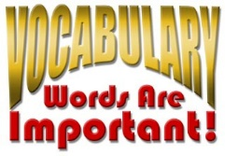 |  | Militia  Alliance  Cede
Assessment  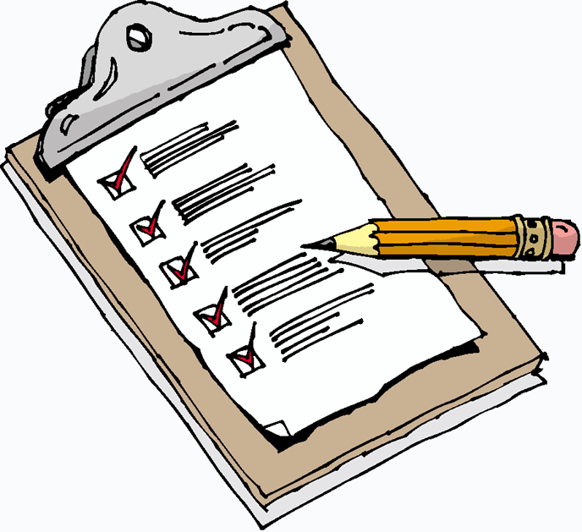 | Claim, evidence Reasoning | INB vocabulary | Historical events chart | Video | chart
GLCE | F1.2 Using the Declaration of Independence, including the grievances at the end of the  document, describe the role this document played in expressing | F1.2 Using the Declaration of Independence, including the grievances at the end of the  document, describe the role this document played in expressing | F1.2 Using the Declaration of Independence, including the grievances at the end of the  document, describe the role this document played in expressing | F1.2 Using the Declaration of Independence, including the grievances at the end of the  document, describe the role this document played in expressing | F1.2 Using the Declaration of Independence, including the grievances at the end of the  document, describe the role this document played in expressing

