Week of  10/23 – 10/27 | Monday | Tuesday | Wednesday  1/2 day | Thursday | Friday
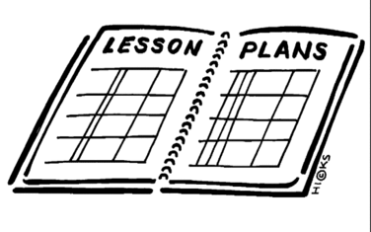  Lesson | 1. Vocabulary dictionaries  2. Type Patriots Pen | 1. Vocabulary Matching  2. Read chapter 6, section 2 together.  3. Use the summarizing graphic organizer to comprehend the text | 1. Vocabulary Sentences  2. Read chapter 6, section 3 together  3. Summarize each section in the Interactive Notebooks. | 1. Read chapter 6, section 4 independently  2. complete the graphic organizer in the interactive notebooks “4 reasons the Americans were able to win the war” | 1. Vocabulary Quiz  2. Complete the chapter 6 study guide.
Content Objective | Students will be able to demonstrate knowledge of the patriots pen theme | Students will be able to demonstrate understanding of the colonists changing view on freedom and equality and their willingness to fight for it by reading about major battles and the turning point of the war. | Students will be able to demonstrate understanding of the colonists changing view on freedom and equality and their willingness to fight for it by reading about the war at home, in the west and at sea. | Students will be able to demonstrate understanding of the colonists changing view on freedom and equality and their willingness to fight for it by reading about the final battle, the peace treaty and the impact of the war on Americans and the world. | Students will be able to demonstrate knowledge of chapter 6.
Language Objective | Students will write to complete the Patriots pen essay. | Students will write to identify the main Ideas of a section of the text book | Students will orally say a sentence using one or more of the vocabulary words. | Students will orally explain the reason that America was able to win the war | Students will orally discuss the chapter 6 review.
Vocabulary | - Mercenary  - Civilian  - Enlist  - Traitor  - Guerrilla
Assessment | Type Patriots Pen | Graphic organizer | Summarize | Graphic organizer | Study guide
GLCE | CCSS.ELA-LITERACY.W.8.2  Write informative/explanatory texts to examine a topic and convey ideas, concepts, and information through the selection, organization, and analysis of relevant content. | F1.3 Describe the consequences of the American Revolution by analyzing the  • Birth of an independent republican government  • Creation of Articles of Confederation  • changing views on freedom and equality  • and concerns over distribution of power within governments, between government and the governed, and among people | F1.3 Describe the consequences of the American Revolution by analyzing the  • Birth of an independent republican government  • Creation of Articles of Confederation  • changing views on freedom and equality  • and concerns over distribution of power within governments, between government and the governed, and among people | F1.3 Describe the consequences of the American Revolution by analyzing the  • Birth of an independent republican government  • Creation of Articles of Confederation  • changing views on freedom and equality  • and concerns over distribution of power within governments, between government and the governed, and among people | F1.3 Describe the consequences of the American Revolution by analyzing the  • Birth of an independent republican government  • Creation of Articles of Confederation  • changing views on freedom and equality  • and concerns over distribution of power within governments, between government and the governed, and among people

